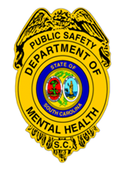
SC Department of Mental Health
Division of Public Safety
7901 Farrow Rd, Building #17
Columbia SC 29203
Telephone: (803) 935-5470
Fax: (803) 935-5492
E-Mail: PublicSafety@scdmh.org

COMPLAINT FORM

It is Public Safety policy to investigate all complaints and take appropriate action. Please use this form to document your complaint, and submit it to SC Department of Mental Health, Division of Public Safety, 7901 Farrow Road, Building #17, Columbia, SC 29203. Complaint forms may be submitted in person, by fax, mail, or email. You may remain anonymous. Attn: Internal Affairs

Complainant Contact Information
Name of Person Filing the Complaint (optional): |  | Date:
Mailing Address: | Telephone:  E-Mail:
What is the best time to contact you?
What is the best method to contact you?

Provide a statement of how you believe you have been violated or treated unfairly. Attach additional pages if necessary.

I acknowledge that I have read this document and understand my obligation to provide information as needed and to cooperate fully and completely with any investigation of this complaint.

Signature: Date:
Rev. 2/20

